**A level Physical Education**

**Year 11-12 Transition work**

Over summer you will be expected to utilise the foundations from GCSE as well as building on this knowledge through research in preparation for A-Levels.

Use the internet to research the body systems. Fill in the blanks on the A3 knowledge organiser – this will be your guide, use this acquired knowledge to answer the exam questions for each topic area.

By competing this work, you will be giving yourself a head start going into A-Levels as well as developing the necessary independent research skills needed for the course.

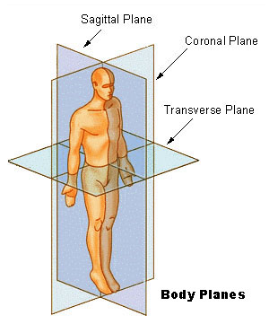

Sagittal plane

Frontal plane

Transverse

plane

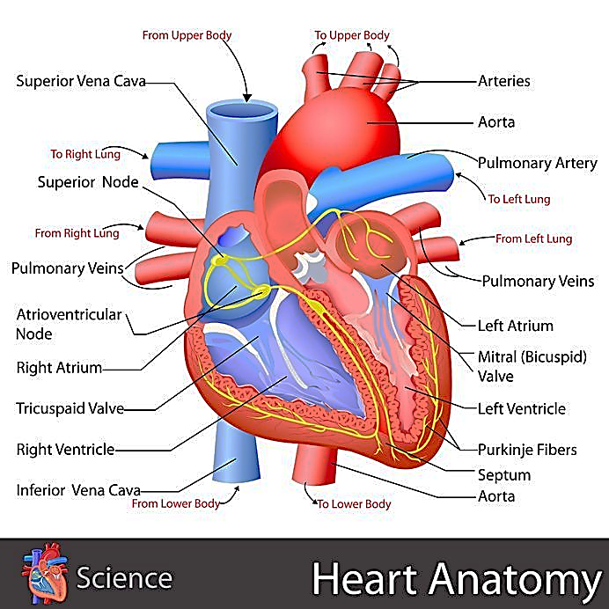

Purkinje Fibres

Tricuspid Valve