Impact on Health and Fitness

**Fill in the table with as many effects of physical activity on   
health and fitness as you can think of.**

|  |  |
| --- | --- |
| **Health** | **Fitness** |
|  |  |

**THE CARDIOVASCULAR SYSTEM…**

**3.1.1.2**

# Cardiovascular system

Cardiac Conduction System

The conduction system involves the electrical impulses that cause the cardiac cycle of the heart. **The cardiac muscle is myogenic**, meaning it generates its own   
impulses. **Outline the order of the cardiac conduction system on the   
diagram below.**

Atrial depolarisation:

Stimulus from the SA node travels across the atria, causing atrial contraction.

Ventricular depolarisation:   
The effect that the AV node has on the ventricles by causing them to contract by providing an electrical stimulus.

Atrial and ventricular repolarisation:Occurs during a brief time period following depolarisation and describes the electrical impulse returning to a baseline value.

**2.**

**1.**

**4.**

**3.**

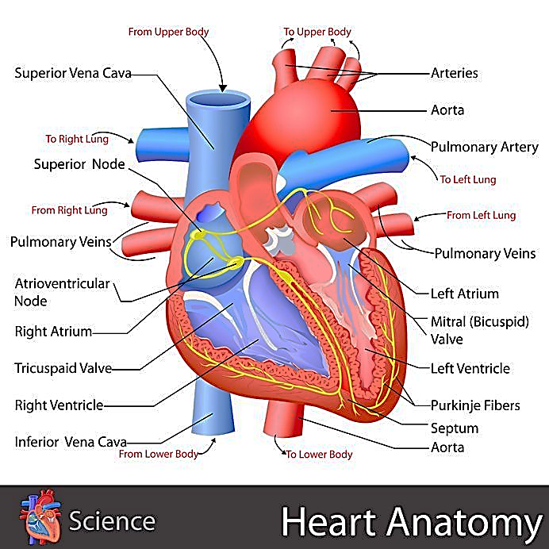

Purkinje Fibres

Tricuspid Valve

The Relationship between Heart Values…

**Complete the equation for cardiac output and explain how training status and exercise intensity can affect each heart value.**

Factors Regulating Heart Rate

**How do these three factors regulate heart rate?**

1. Neural

2. Hormonal

3. Intrinsic

Cardiovascular Drift and   
A-VO2 Difference

* **Cardiovascular drift** – the increase in heart rate which occurs despite no change in the intensity of exercise.
* **Arteriovenous oxygen difference (A-VO2 diff)** –the difference in oxygen concentration between the arteries and veins.
* High-intensity exercise will result in a greater A-VO2 diff as more oxygen is taken out of the arteries to fuel muscular contractions. However, a plateau will be reached when more oxygen cannot be removed from the arteries.
* Trained athletes will have higher starting A-VO2 diffs and will experience a bigger change during exercise.
* Regular training can increase the A-VO2 diff due to: *greater capillary density, greater alveoli density* and *greater myoglobin in the muscles.*

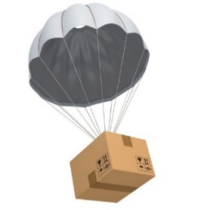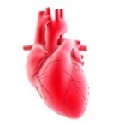

Transportation of Oxygen

Oxygen is transported within the body in association with:

* **Haemoglobin** – the oxygen-carrying component of red blood cells
* **Myoglobin** – the oxygen-carrying component of the muscle tissue

The graph shows an oxyhaemoglobin dissociation curve which displays the **Bohr shift** during exercise of different intensities.

The Bohr shift is demonstrated by the line shifting to the right as the conditions within the blood become more acidic (reduced pH due to increased levels of CO2) during higher-intensity exercise.

Factors influencing Bohr shift include:

1. Increase in CO2
2. Decrease in pH – due to increase in CO2
3. Increase in temperature

Venous return:

The rate at which blood returns to the heart.

As intensity increases:

Blood redistribution needs to be quicker otherwise cardiac output decreases. Exercise increases it through the **muscle pump** and **respiratory pump** which force blood back to the heart. This process is also aided by **pocket valves** in the veins, **smooth muscle** in the walls of the blood vessels and **gravity**. Venous return is quickest in the arteries and during **systole** as systolic blood pressure is larger than diastolic.

During recovery the lower venous return results in a lower stroke volume. This is due to reduced stretching of the ventricles with a low venous return (**Frank-Starling law**).

PO2 (mmHg)

Oxyhaemoglobin (% saturation)

Moderate intensity

Rest

High intensity

Redistribution of Cardiac Output

**During exercise our blood needs to redistribute to working muscles. Describe the methods given below:**

|  |  |
| --- | --- |
| Vascular shunt  Mechanism which directs blood to the exercising muscles through vasodilation and vasoconstriction.  Redistribution of blood during exercise:  ↑ blood flow to the skeletal muscles in order to supply them with oxygen and nutrients and to remove carbon dioxide  ↑ blood flow to the heart to provide additional oxygen, as it has to work harder during exercise  ↑ blood flow to the skin in order to regulate body temperature  ↓ blood flow to some abdominal organs to allow for greater blood flow to active body parts | Arterioles  • Widen (vasodilation) to allow more blood through  • Narrow (vasoconstriction) to reduce blood flow |
| Pre-capillary sphincters  Allow / do not allow the flow of blood into the capillaries, where gas exchange occurs. |

# Respiratory system

**THE RESPIRATORY SYSTEM…**

**3.1.1.3**



**Lung Volumes**

**=**

**×**

The respiratory system consists of a number of structures (outlined in the diagram below) which allow gasses to be transferred between the body and the external environment. This is an important process during exercise when large volumes of oxygen are required by the muscles and large volumes of carbon dioxide need to be removed from the body.

There are a number of different lung volumes which can be measured in order to determine how a person’s respiratory system is functioning. These volumes will change depending on the level of physical activity, the training status and the health of the person.

**Complete the table below by defining each of the lung volumes, identifying a   
typical resting value and indicating how this volume would change during exercise.**

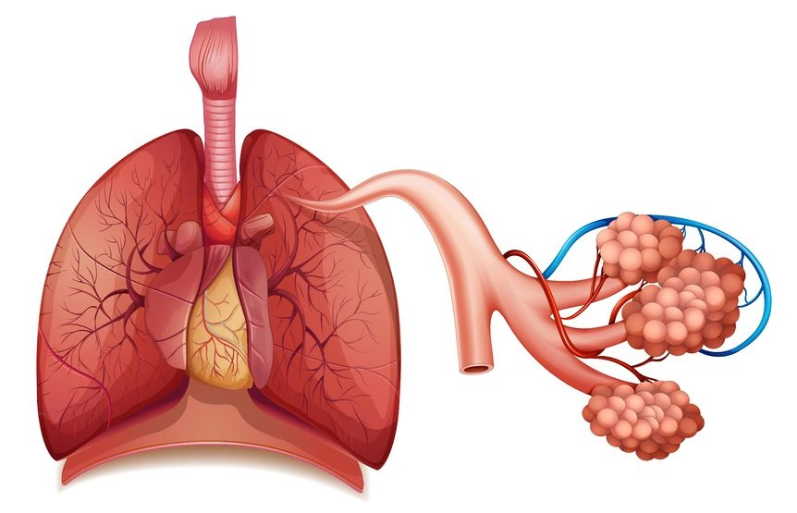

**Trachea**

**Bronchioles**

**Diaphragm**

**Bronchi**

**Heart**

**Alveoli**

**Pulmonary Arteriole**

**Pulmonary Vein**

**Lung**

|  |  |  |  |  |  |
| --- | --- | --- | --- | --- | --- |
|  | **Tidal volume** | **Minute ventilation** | **Residual volume** | **Expiratory reserve volume** | **Inspiratory reserve volume** |
| **Definition** |  |  |  |  |  |
| **Typical resting value** |  |  |  |  |  |
| **Change during exercise** |  |  |  |  |  |

**Gas Exchange during Exercise**

**Dissociation of oxyhaemoglobin**

In a high partial pressure of oxygen (e.g. at the lungs), oxygen binds more readily to haemoglobin. As this partial pressure decreases (e.g. at the exercising muscles) oxygen is more readily released. As exercise intensity increases, the partial pressure of oxygen decreases and so oxygen is easily released from haemoglobin.

As exercise intensity increases, there is a larger **pressure gradient** between CO2 andO2 levels at the sites of gas exchange.

**At the alveoli:**

**At the muscles:**

**Gas Exchange**

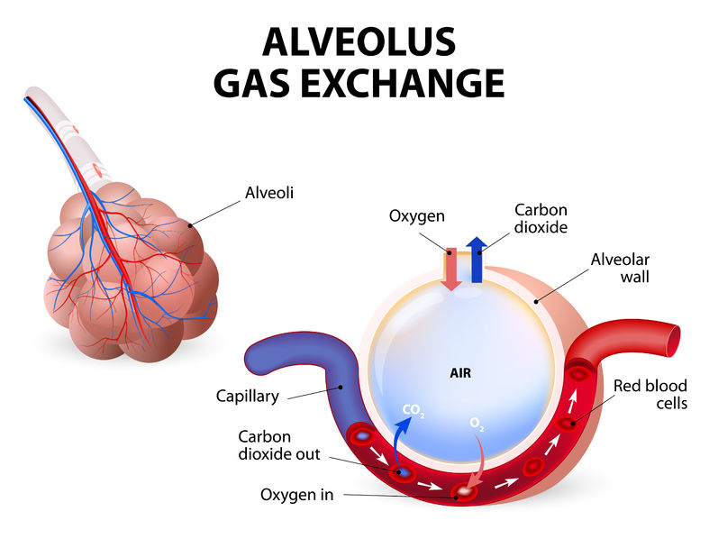

**Regulation of Breathing Rate**

The respiratory control centre of the brain is made up of the **inspiratory control centre** and the **expiratory control centre**. These two centres work together to regulate breathing at rest and during exercise without conscious thought and, therefore, require different receptors to send them information in order to control breathing rate.

**Explain how neural, chemical and hormonal factors   
control breathing rate.**

**1. Neural**

**2. Chemical**

**3. Hormonal**

**Explain how gas exchange occurs at   
the alveoli and the muscles.**

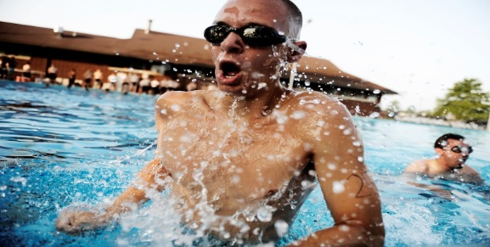

# C:\Users\EllenaHeywood\Downloads\Oxyhaemoglobin_dissociation_curve.pngFile:Medicine-ball-biceps-curl-on-stability-ball-1.gifhttps://upload.wikimedia.org/wikipedia/commons/a/a3/One-arm-preacher-curl-2.gifNeuromuscular system

‘All or none’ law

Each muscle fibre controlled by a motor unit is either fully contracted or not contracted at all.

Therefore, a muscle fibre cannot partially contract.

They can contract in different ways depending on how they are innervated.

Types of Contraction

Muscles have many different roles within the body, namely **movement**, **heat production**, **digestion** and **maintaining posture**. The capability of the muscles to undergo contraction and relaxation is the key enabler of movement. Muscles can contract in different ways depending on what action they are trying to perform.

**Provide a definition for the following types of contraction.**

**Isotonic:**

**Eccentric:**

**Concentric:**

**Isometric:**

Muscle contractions aren’t all the same. Sometimes muscles contract and lengthen, sometimes they contract and shorten and sometimes they contract and don’t change length at all.

The Recruitment of Muscle Fibres

**Describe what proprioceptive neuromuscular facilitation is and the role that muscle spindles and the Golgi tendon organ play.**

Proprioceptive Neuromuscular Facilitation

The autonomic nervous system is responsible for subconsciously controlling muscular contractions.

There are two systems which make up the autonomic nervous system:

* The **parasympathetic** nervous system is responsible for actions that occur when resting.
* The **sympathetic** nervous system is responsible for actions when active.

Both nervous systems innervate the muscle tissues by sending a nervous impulse to them.

The Nervous Systems

Muscle Contraction during Exercise and Recovery

There are two different types of muscle fibres – slow twitch and fast twitch. There are two types of fast-twitch fibres – fast oxidative glycolytic (type IIa) and fast glycolytic (type IIb).

**Identify the characteristics of each muscle fibre type in the table below and give one sport each fibre type would be beneficial in.**

|  |  |  |
| --- | --- | --- |
| Slow oxidative (1) | Fast oxidative (11a) | Fast glycolytic (11b) |
|  |  |  |
| **Sport:** | **Sport:** | **Sport:** |

**The Size Principle (Henneman et al. 1974)**

Smaller motor units are recruited first as they have a smaller firing threshold than larger motor units.

**Muscle fibre recruitment**

Muscle fibre recruitment is dependent on the intensity of the exercise; higher-intensity exercise requires more force, with lower-intensity exercise requiring less force.

**The Neuromuscular System**

**3.1.1.4**

# Musculo-skeletal system & Movement analysis

**The Musculoskeletal System and Movement Analysis**

**3.1.1.5**

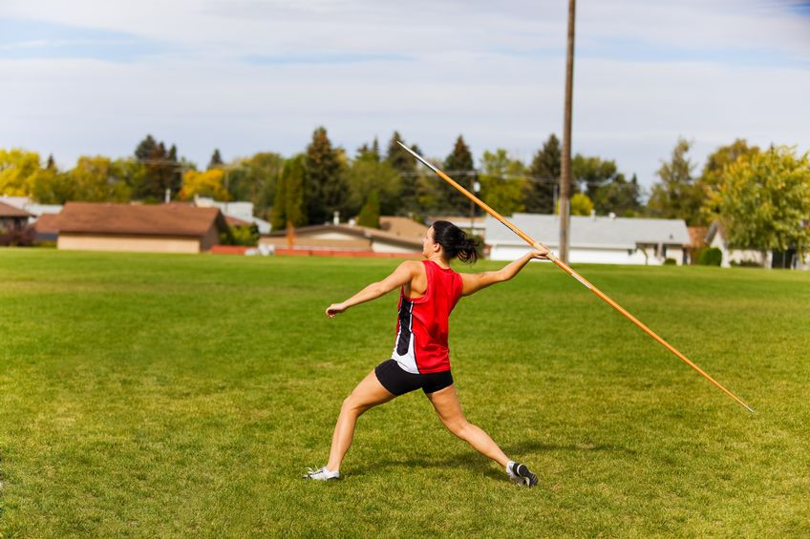

|  |  |  |  |  |  |
| --- | --- | --- | --- | --- | --- |
| **Joint** | **Type** | **Articulating Bones** | **Joint Action** | **Agonist** | **Antagonist** |
| **Shoulder** | Ball and Socket | Scapula and humerus | Flexion |  |  |
| Extension |  |  |
| Adduction |  |  |
| Abduction |  |  |
| Horizontal abduction |  |  |
| Horizontal adduction |  |  |
| **Elbow** | Hinge | Humerus, radius and ulna | Flexion |  |  |
| Extension |  |  |
| **Hip** | Ball and Socket | Femur and pelvis | Flexion |  |  |
| Extension |  |  |
| Adduction |  |  |
| Abduction |  |  |
| Horizontal abduction |  |  |
| Horizontal adduction |  |  |
| **Knee** | Hinge | Femur and tibia | Flexion |  |  |
| Extension |  |  |
| **Ankle** | Hinge | Talus, tibia and fibula | Plantar flexion |  |  |
| Dorsiflexion |  |  |

Axes of Rotation

There are three axes of rotation, each with an associated direction for your body to rotate. **Give as many sporting movements which occur around each axis.**

**Transverse:**

**Frontal**:

**Longitudinal:**

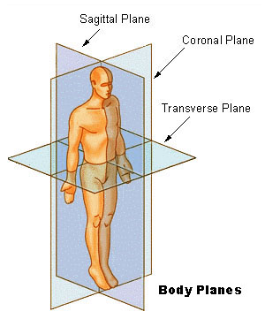

Sagittal plane

Frontal plane

Transverse

plane

Planes of Movement

There are three planes of movement, each with an associated dimension for your body   
to move in. **Give as many sporting movements which occur in each plane as you can think of.**

**Frontal:**

**Transverse:**

**Sagittal:**



Transverse

Longitudinal

Sagittal

Frontal

Transverse

**Holding the leg outstretched**

**Hip**

**Kicking backswing**

**Knee and ankle**

**Javelin withdrawal phase**

**Elbow and shoulder**

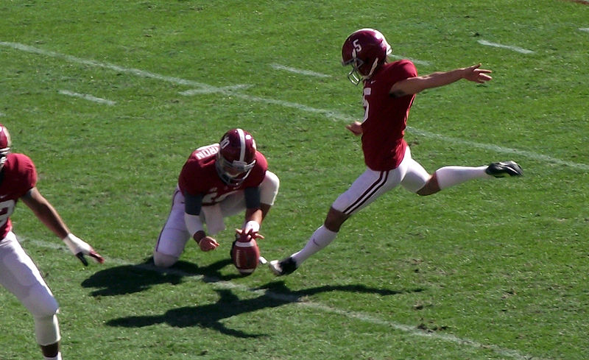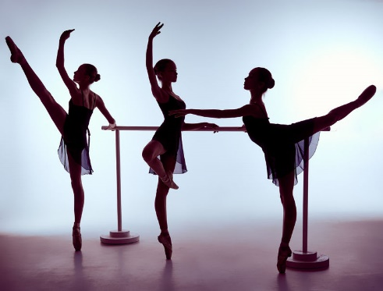

Analysis of Movement

Analysing movement is a key concept of biomechanics,   
and is completed to help improve sport performance by   
improving the efficiency of sporting movements, and   
identifying how technique could be improved.

When analysing movement you should refer to:

• the movement produced

* the plane of movement
* the axis of movement

• the type of muscle contraction taking place

**Analyse the movements in the images below:**

**Identify the agonist and antagonist muscles used in each of the following movements.**