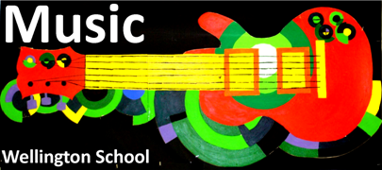

**Music Department Activities**

**Week commencing 20th February 2017**

|  |  |  |  |
| --- | --- | --- | --- |
|  | **Before School**  **7.45 a.m. – 8.15 a.m.** | **Lunchtime**  **1.25 p.m. – 2.00p.m.** | **After School**  **3.05 p.m. – 4.15 p.m.** |
| Monday |  | **GCSE & A-Level Composition / Performance* (can use each day)** | **GCSE & A-Level Composition / Performance**  Room 18  Mrs Moorhouse |
| Tuesday |  | **SING – new & old members welcome**  Room 18  Mrs Moorhouse |  |
| Wednesday |  | **Crochet Club**  Room 18  Mrs Moorhouse  **GCSE & A-Level Composition / Performance* (can use each day)** | **GCSE & A-Level Composition / Performance**  Room 18  Mrs Moorhouse  **Wellington Band**  Vale Hall  Mr Horne |
| Thursday |  | **Music Theory Club &**  **GCSE & A-Level Composition / Performance**  Room 18  Mrs Moorhouse  **Wellington Rock Band**  Room 17  Mr Horne | **GCSE & A-Level Composition / Performance**  Room 18  Mrs Moorhouse |
| Friday |  | **SING WITH 7S**  Room 18  Lucy & Eleanor  **Samba Band**  Room 17  Mr Black and Mr Horne |  |

**Key word of the Week**

**Experimental**

Experimental music is music composed by a generation of composers who wanted to challenge the traditional view of music and experiment with how the audience can interact with the music.

**Music of the Week**

**‘ 4’33’’ ’ by**

**John Cage**

**Did You Know?**

**The composer Mike Batt had to pay a 6 figure sum to John Cage for breach of copyright for a song called ‘Track 13’. It is claimed that John Cage owned the copyright for a ‘silent’ piece of music.**