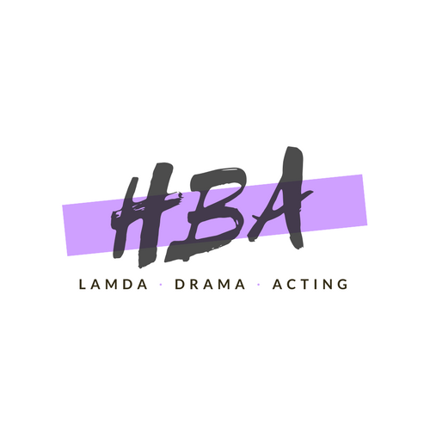

LAMDA Overview

ABOUT LAMDA
LAMDA are an awarding organisation, delivering world-renowned qualifications in communication and performance and inspiring the next generation of confident communicators through their examinations in drama, literature and poetry.
LAMDA believe drama has the power to transform lives. They want more people to share in this experience through training, qualifications, work, productions and facilities.
LAMDA is one of the UK’s oldest and most respected awarding bodies. They have been offering practical examinations in communication and performance subjects for over 130 years. In this time, their qualifications have helped hundreds of thousands of candidates of all ages and abilities to develop lifelong skills.

LAMDA exams are about achievement – recognising and rewarding the endeavours of each individual – but they are also about empowerment. LAMDA’s ultimate aim is to provide all people with the opportunity to develop the life skills they need to be a success: attributes such as self-confidence and the ability to communicate clearly and present ideas.

At the heart of LAMDA examinations is the recognition that their qualifications are for everyone. Across the globe, their examinations unite learners of all ages, abilities, backgrounds and cultures in enthusiasm for the English language and a desire to develop skills for life.

LAMDA’s Level 3 recognised qualifications are included in the UCAS Tariff. LAMDA has been recognised as an awarding organisation by Ofqual, the Office of Qualifications and Examinations Regulations in England

LAMDA ACTING QUALIFICATION

PURPOSE OF THE QUALIFICATION

LAMDA Graded Examinations in Performance: Acting are designed to develop the skills necessary to communicate dramatic text to an audience.
Learners who prepare themselves appropriately will develop:
1 Interpretative skills
2 Technical skills
3 Knowledge of the performance process.

BROAD OBJECTIVES OF THE QUALIFICATIONS

1 Interpretative skills
The learner(s) will be required to:
- explore style, form, character, subtext and context in order to realise the specific demands of the text
- engage with character and situation in order to create a sense of reality.

2 Technical skills
The learner(s) will be required to:
- develop skills in voice, diction and movement.

3 Knowledge of the performance process
The learner(s) will be required to:
- know and understand the chosen selections

REGISTRATION FORM
(Please Print)

Student INFORMATION
First name: |  | Last Name: |  |  | Age: |  |  | Form:
Parent / Guardian Name: |  |  |  | Home phone no.: |  |  |  | Mobile phone no.:
Parents Email:
Secondary Contact Name: |  |  |  | Home phone no.: |  |  |  | Mobile phone no.:
Course Selection: Acting Solo Acting Duo |  |  |  | If acting duo selected name of preferred partner (if known):

General Data Protection Regulation
HBA would like to contact you from time to time, perhaps with news and updates on courses, summer schools and announcements. We will not send spam or generic newsletters. HBA will not share your information with any third parties. HBA will keep all data secure and will delete data if not used for more than 24 months. If you are happy to receive communications from HBA please tick to opt in to provide your consent.

I give permission for HBA to contact me

Terms & Conditions
I confirm that I (print name of parent/guardian) : ____________________________ give my permission for (print name of young person) : _______________________________ to attend LAMDA Classes specified above with the named teacher (or a suitably qualified substitute teacher). I understand that in the event of illness or accident that if the activity leader considers there is a need for medical attention, medical aid will be sought and all attempts will be made to contact parents / guardians. In the event of no contact being possible, a healthcare professional, following strict guidelines, will decide whether examination and subsequent treatment are necessary.

Lessons will be delivered during the school day on a rota basis to ensure your child does not miss a portion of the same lesson each week. You will be contacted by the school with your child’s allocated day and time slot in due course. Group lessons cost £8 each, individual or paired lessons are available upon request. Payment is required upfront per term. Payment must be made in full and advance to Hannah Bounds, Sort Code 01-09-31, Account Number 54727030. An invoice will be emailed following student registration. Fees will not be refunded due to student absence. Lessons will either be rescheduled or refunded if teacher absence occurs and a suitably qualified substitute teacher cannot provide cover. If unforeseen circumstances occur that result in a class being cancelled an additional class will be rescheduled or the class will be refunded.

Official LAMDA Examinations are not included in the lesson fee. The exams require an additional fee inclusive of admin fees. Example fees for the various accreditation levels can be found on the LAMDA website at www.lamda.ac.uk

Please submit completed forms to the School Office or alternatively you can request an electronic version by emailing hannah@hbacting.co.uk and submit the form on email by return.

PArental / Guardian Consent
 | Patient/Guardian signature |  |  |  |  |  | Date

Photo Policy & Consent FORM

We’d like to post some photos of our classes, performances, and general LAMDA Course experience. We respect your feelings about posting pictures on the web and will not post pictures of students without a signed consent form found below. If you do not fill out this form, we will assume you do not want your Child’s image used by HBA.

Photo use policy
HBA requires a signed release form from the subject of any photograph or image used on web sites, brochures, or advertisement. HBA will not publish any image of a minor unless his or her parent or legal guardian has signed a permission form. Group photographs do not require consent before publication.

STUDENT INFORMATION
First name: |  | Last Name: |  |  | Age:
Parent / Guardian Name:

PArental / Guardian Consent
Photo release and consent

I hereby grant permission to HBA to use my image or that of my child(ren) listed below on its website or in other publications without further consideration. I understand that no names will be used on the web site or in publications unless specific permission, verbal or written, is given. I hereby attest that I am the legal parent or guardian of the child(ren) listed above. This consent is effective until such time as I revoke it in writing and provide a copy of the Revocation to HBA.

 | Patient/Guardian signature |  |  |  |  |  | Date

